Energy Form Transformation Webquest: Record your answers to each of the following in your Science Notebook. The links can be found on my website if you don’t want to write out the addresses.

Activity One: Forms of Energy
http://glencoe.mcgraw-hill.com/sites/dl/free/0078742722/160350/00076705.html

- Watch the video clip
- Answer the quiz questions. Check and change any incorrect responses.

Quiz Answers
1.
2.
3.
4.
5.
6.
7.
8.
9.
10.

Activity Two: Energy Equations
http://www.glencoe.com/sites/common_assets/science/virtual_labs/E04/E04.html

Energy can be transformed/converted from one form of energy into another.

- Go through each of the 5 sequences. You will need to determine what type of energy transformation is taking place. Once you have the sequences in the correct order write them down, make sure to label the energy transformations.

Sequence 1:
Sequence 2:
Sequence 3:
Sequence 4:
Sequence 5:

Activity Three: Cat-traption http://www.learner.org/workshops/energy/cattraption/catrunthru.html
- Watch the cat-traption activity. Then click on On to Cat-Traption Activity.
- Answer each questions A-E by clicking on the letter and the top.
- Write your answer with an explanation.
Answers
A.
B.
C.
D.
E.

Activity Four: Energy Transformations
http://media.pearsoncmg.com/bc/bc_campbell_biology_7/media/interactivemedia/activities/load.html?8&A
Complete this activity. Make sure you view the three parts. Write and complete the following sentences from info at the site:
- Conservation of Mass is…
- The energy from the arrow is converted to…
- The arm gets its energy by converting…

Conclusion
Students should be able to answer the following questions after completing the five activities.
Summative Quiz:
1. "Energy cannot be created nor destroyed in any chemical reaction. It can only be changed from one form to another." This is known as the Law of:
A. Energy Transformation
B. Conservation of Energy
C. Energy Transfer

2. During energy transformation, energy is never ____________.
A. used to increase an object's potential energy
B. released as heat
C. created or destroyed

3. As energy transformations occur within a system, the total energy of the system _________.
A. remains constant
B. decreases
C. increases

4. Which of the following objects has kinetic energy?
A. a ball rolling across the floor
B. leaves lying on the ground beneath a tree
C. a bicycle parked at the top of a hill

5. ______________ is the energy stored in an object due to its position.
A. Kinetic energy
B. Thermal energy
C. Potential energy

- The diagram below shows a roller coaster. Use this diagram to answer the next question.
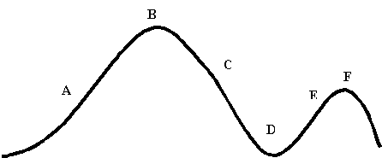
(From: http://galileo.phys.virginia.edu/education/
outreach/8thgradesol/EnergyPendulum.htm)
At what point in the journey of the roller coaster is potential energy transforming into kinetic energy?
- Point A
- Point B
- Point C
- Point D
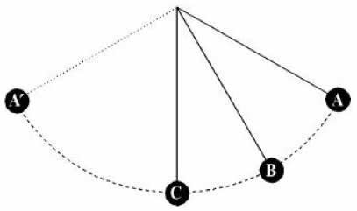
(From: http://albertgrasmarti.org/agm/recerca-divulgacio/pendulum-TPT.pdf)
In the figure above
  - position A is the point of maximum potential energy and minimum kinetic energy.
  - position B is the point of maximum potential energy and minimum kinetic energy.
  - position A is the point of maximum kinetic energy and minimum potential energy.
  - position B is the point of maximum kinetic energy and minimum potential energy.
- Below is a figure of a pendulum. The letters represents specific points that the pendulum passes through in its swing. Use this figure to answer the next question.
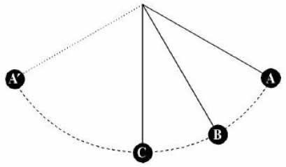
(From: http://albertgrasmarti.org/agm/recerca-divulgacio/pendulum-TPT.pdf)
In the figure above, the letter representing the point where kinetic energy and potential energy are equal is
- Point A
- Point B
- Point C
- Point A'

